1. Create hellosign.com account. (email and username)
2. Click the integrations menus

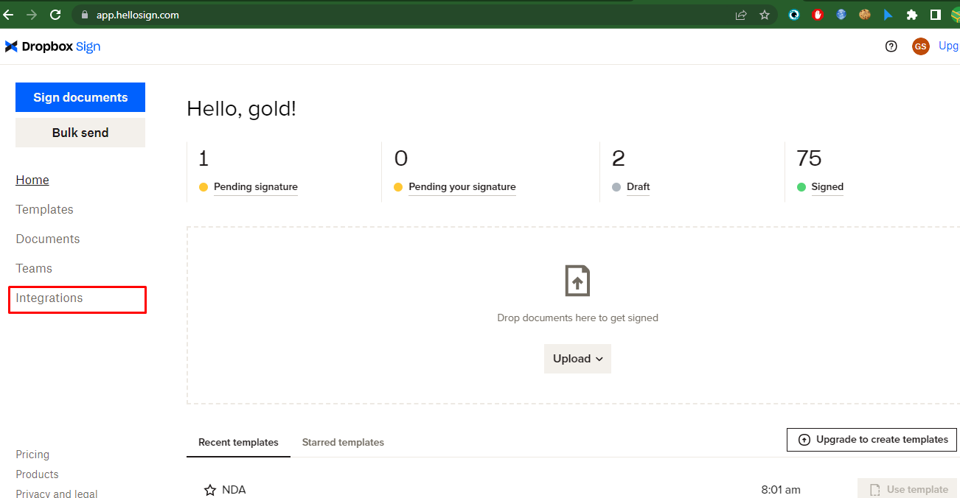

1. And click the API

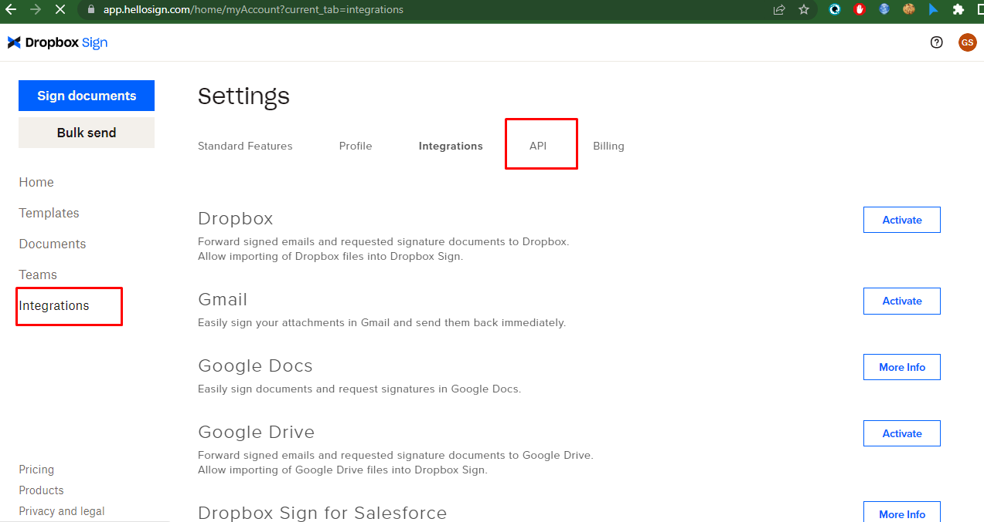

1. And create api key

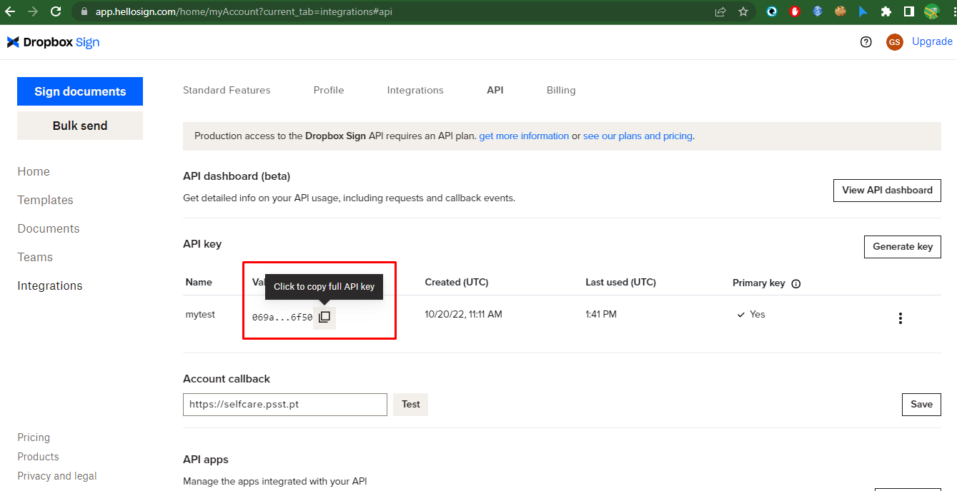

1. Insert your domain url like this in the form and save it.

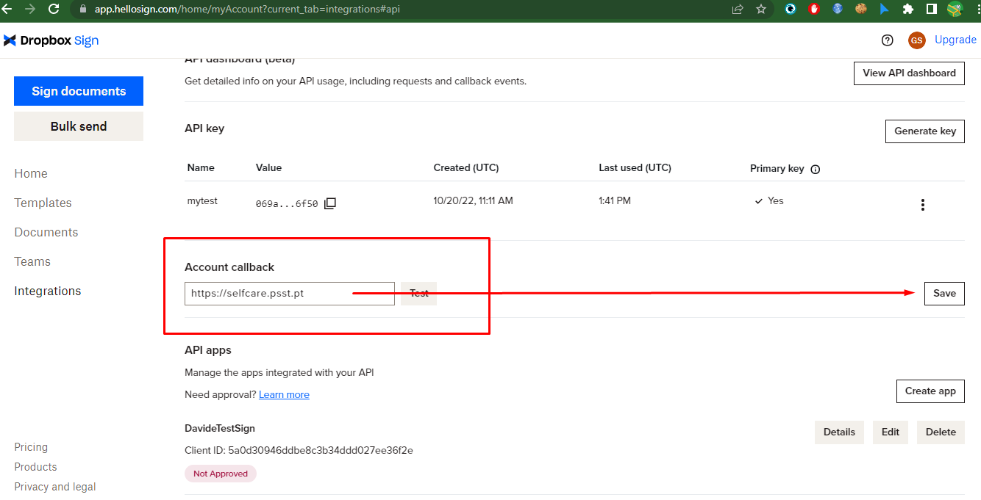

1. Click edit button

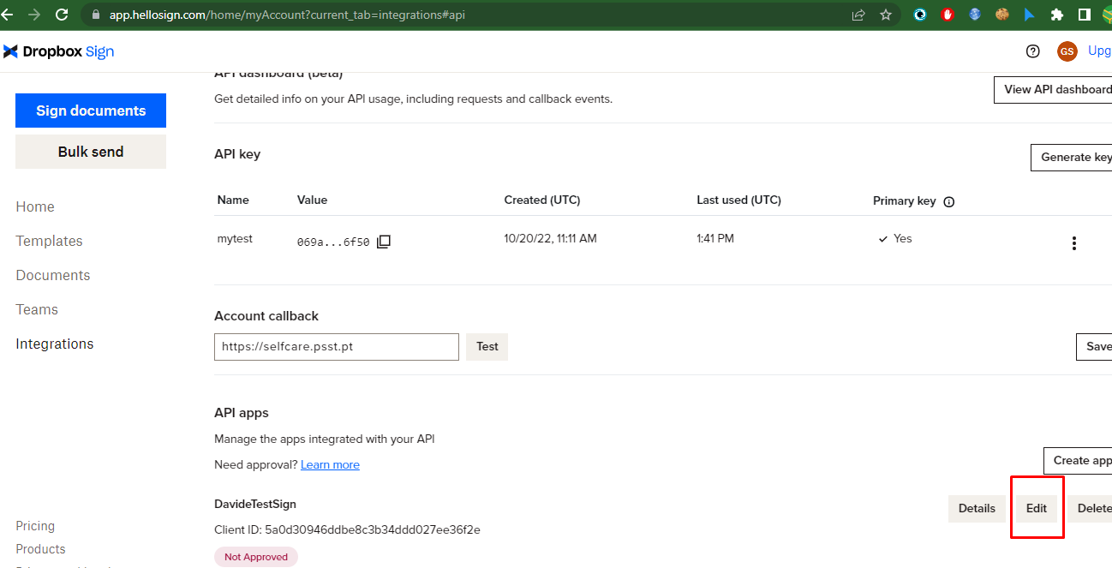

1. You have to add the info in the forms like this screen

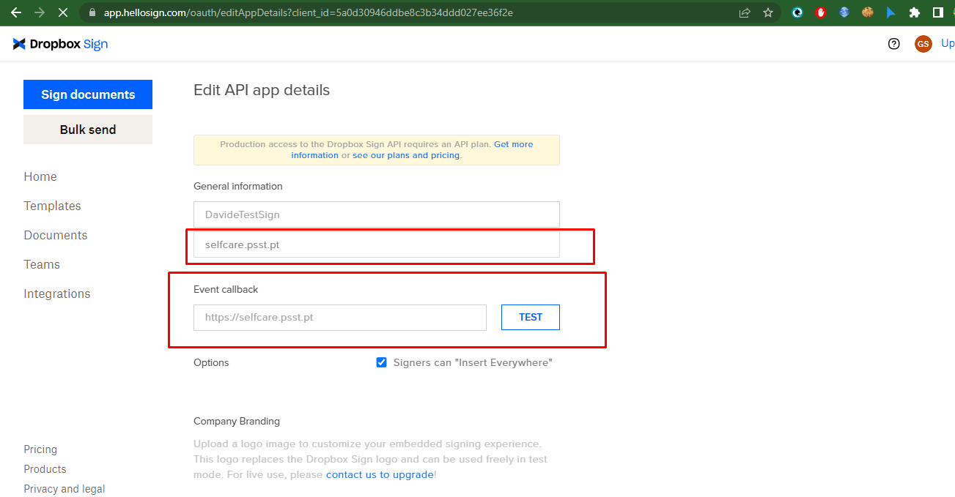

Also in the same page you have to insert data in this form like this screen.

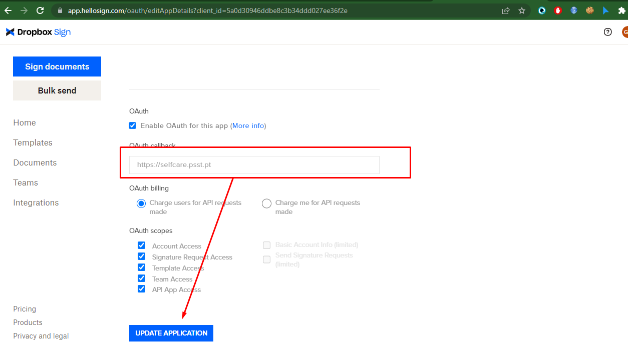

And click the button.

And have to confirm the account callback form again.

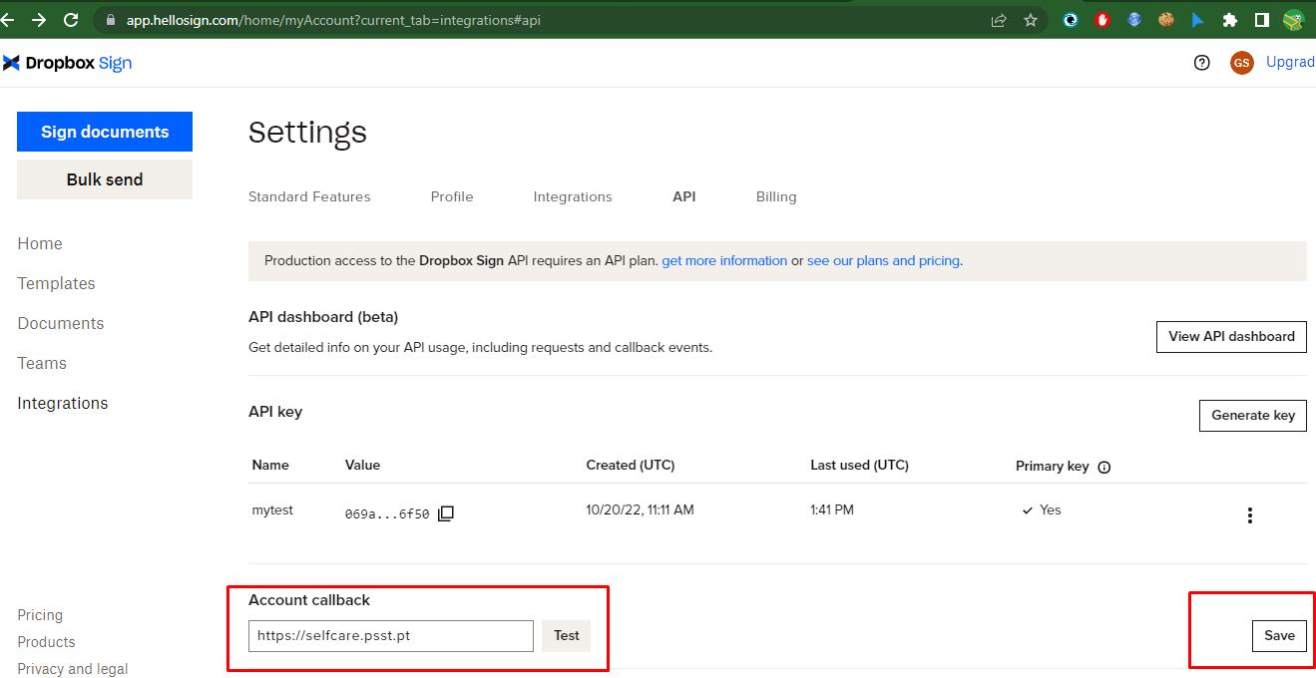

Then you can get the userEmail, username, API key an ClientID in this page.

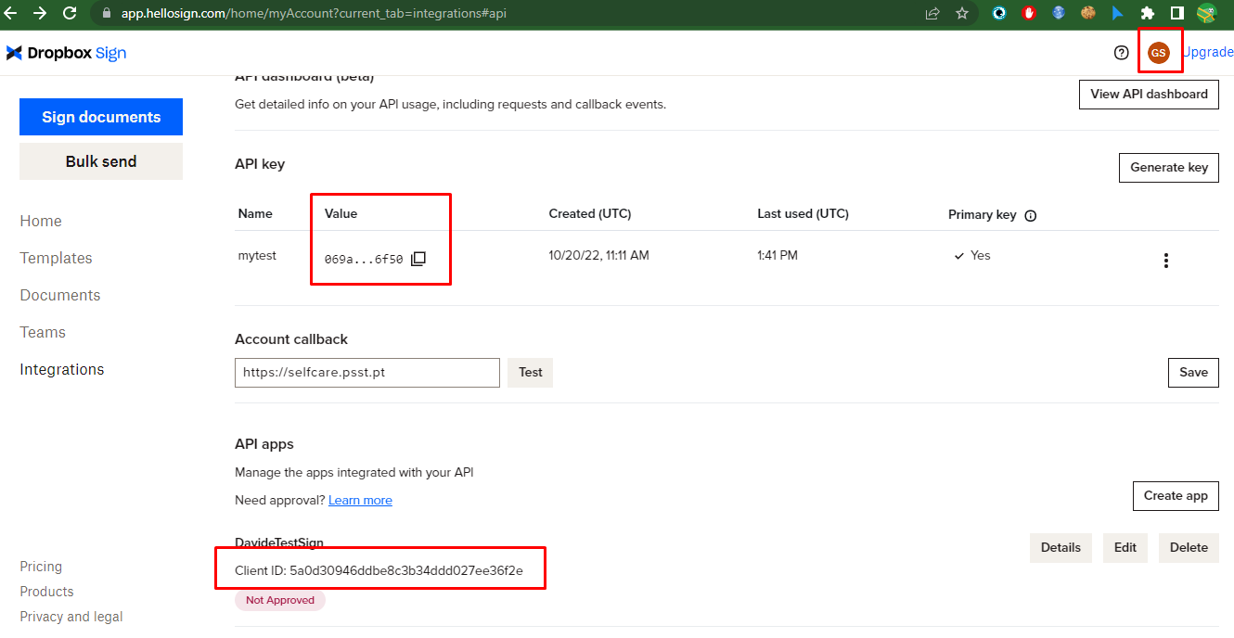

1. We have to make the template for next step.

We can use our pdf file to create the template.

We can check this guide to make the template.

<https://developers.hellosign.com/docs/templates/walkthrough/>

To create the template

<https://app.hellosign.com/prep-and-send/4278a986dc6f7dc14eea410365e691e47447e545/documents>

Click this link.

And upload the template PDF file for our project.

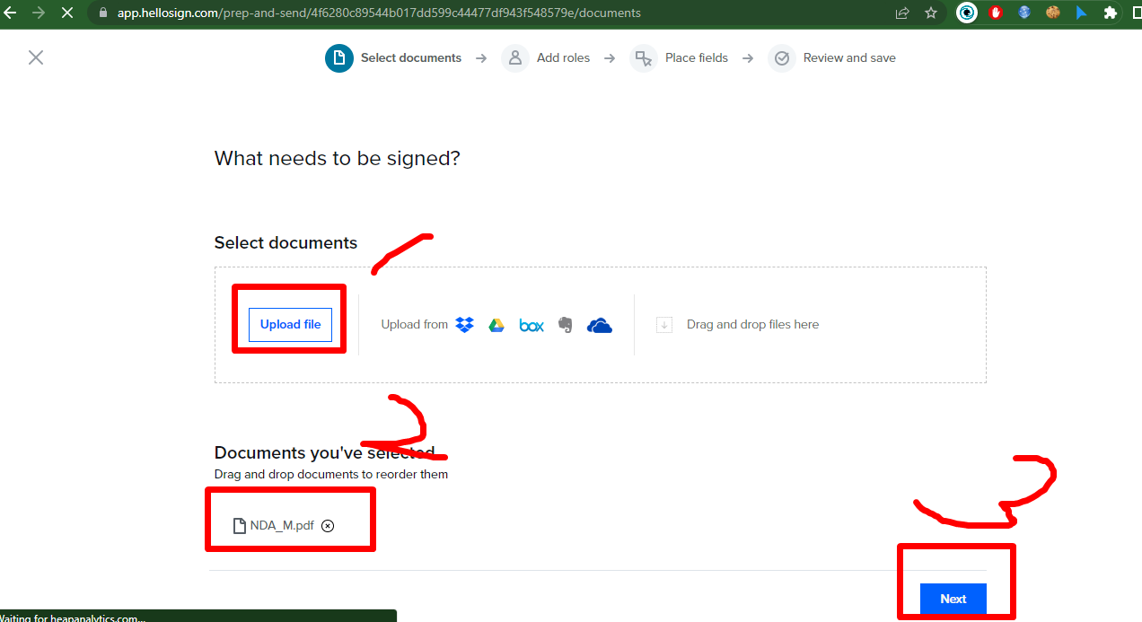

And click next button.

9. And then add the signer roles like this.

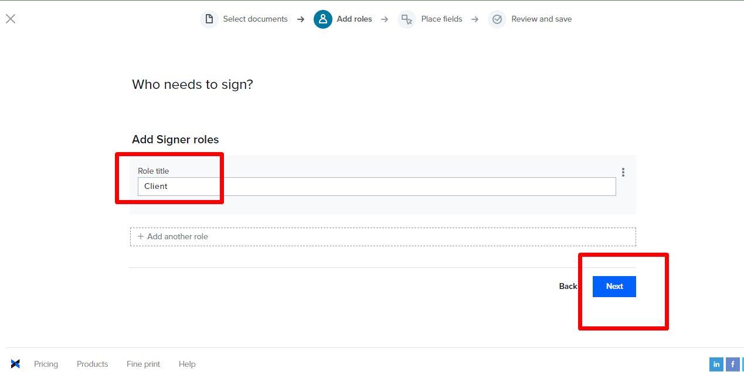

And click the next button

10 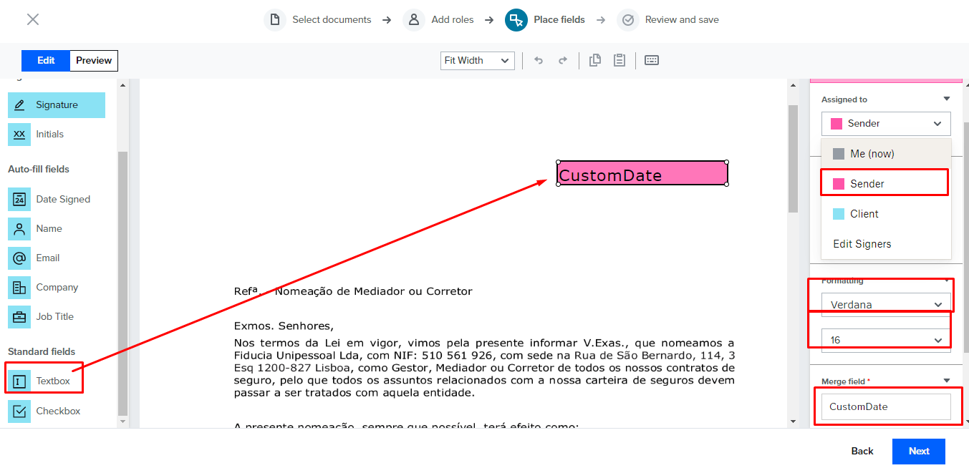

You have to set all like this screen for date filed. And click the next button.

11. 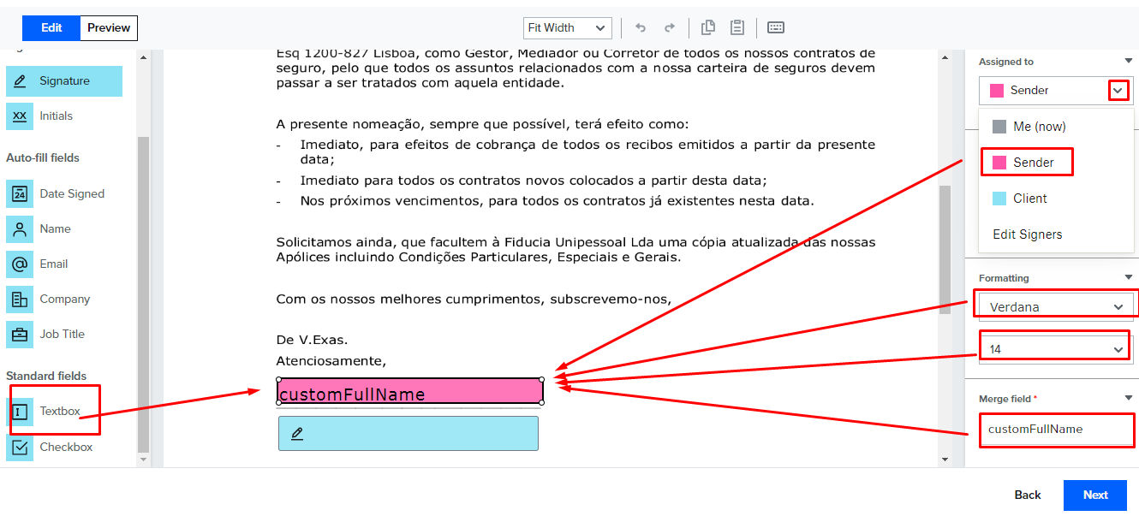

10 and 11, you have to get the value of merge filed.  
You have to add the value in the setting.py.

12 . 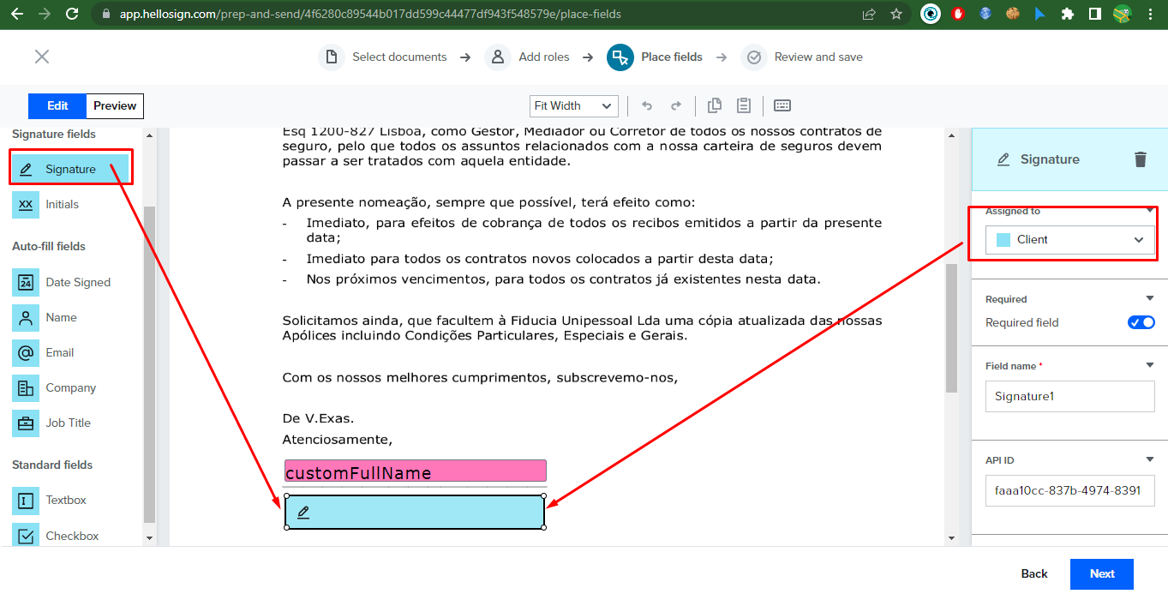

Add the signature filed on here like this screen.

And click next button

13 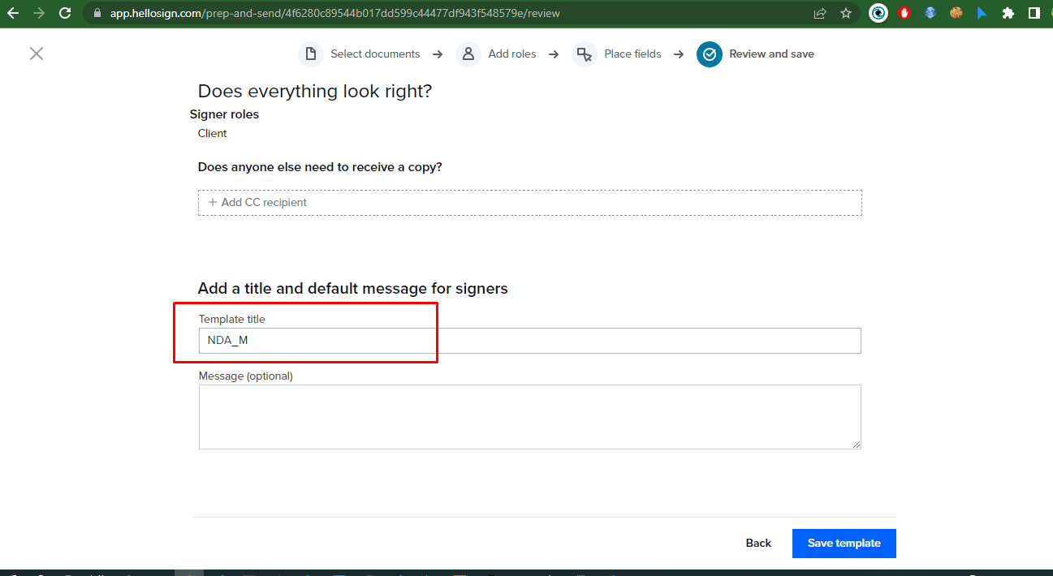

You can add the template name like you want and click save template button.

14 . You can see the template id.

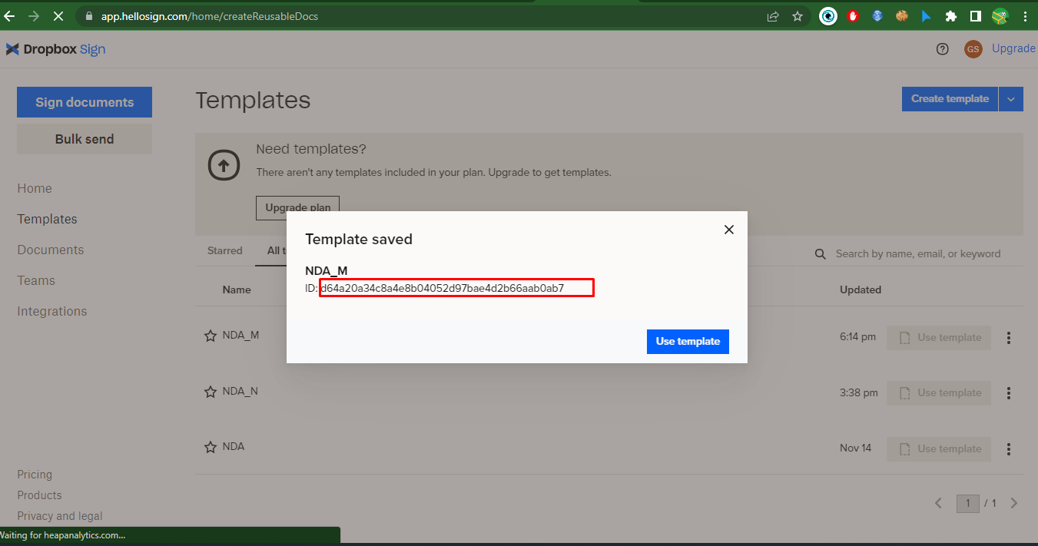

You have to add the template id in the settings.py and click the X button

Then hellosign setting is finined.